MLDL
PRACTICAL 3
Name: Payal Dara
Class: D15C
Roll no: 56
Batch: C

AIM:-
Apply Decision Tree and Random Forest for classification tasks

1. Dataset Source
Dataset Name: Breast Cancer Wisconsin (Diagnostic) Dataset
Source: UCI Machine Learning Repository
Dataset Link:
https://archive.ics.uci.edu/ml/datasets/Breast+Cancer+Wisconsin+(Diagnostic)

2. Dataset Description
The Breast Cancer Wisconsin dataset contains medical diagnostic measurements extracted from digitized images of breast tissue samples. The objective is to classify whether a tumor is malignant or benign.

Dataset Size
- Number of Instances: 569
- Number of Features: 30 numerical features
- Target Variable: Diagnosis
  - M → Malignant
  - B → Benign

Dataset Characteristics
- Medical diagnostic dataset
- No missing values
- All features are continuous
- Binary classification problem

Feature Description (Examples)

Feature | Description
radius_mean | Mean radius of tumor
texture_mean | Texture of tumor
perimeter_mean | Tumor perimeter
area_mean | Tumor area
smoothness_mean | Smoothness of tumor surface
Target Variable:
- Diagnosis = 1 → Malignant
- Diagnosis = 0 → Benign

3. Mathematical Formulation of Decision Tree
A Decision Tree recursively splits data based on feature values to maximize class purity.

Splitting Criterion (Gini Index)
Gini=1−∑i=1cpi2Gini=1−i=1∑c​pi2​
Where:
- pipi​ = probability of class i
- cc = number of classes

Entropy (Alternative Criterion)
Entropy=−∑i=1cpilog⁡2(pi)Entropy=−i=1∑c​pi​log2​(pi​)

Information Gain
IG=Entropy(parent)−∑j=1k∣Dj∣∣D∣Entropy(Dj)IG=Entropy(parent)−j=1∑k​∣D∣∣Dj​∣​Entropy(Dj​)
The feature with maximum information gain is selected for splitting.

4. Algorithm Limitations (Decision Tree)
- Prone to overfitting
- Sensitive to noise and outliers
- Small data changes can alter tree structure
- Bias towards features with more levels
- Deep trees reduce generalization ability

5. Methodology / Workflow

Steps Followed
- Load Breast Cancer dataset
- Encode target variable (M → 1, B → 0)
- Split dataset into training and testing sets
- Train Decision Tree classifier
- Apply pruning using max_depth
- Predict test data
- Evaluate using classification metrics

Workflow Diagram (Textual)
Dataset → Preprocessing → Train-Test Split
→ Decision Tree Training → Prediction → Evaluation

6. Performance Analysis

Evaluation Metrics Used
- Accuracy
- Precision
- Recall
- F1-Score
- Confusion Matrix

Example Results

Metric | Value
Accuracy | 0.93
Precision | 0.91
Recall | 0.94
F1-Score | 0.92

Interpretation
- High accuracy indicates effective classification
- Balanced precision and recall show reliable predictions
- Decision Tree performs well on structured medical data

7. Hyperparameter Tuning (Decision Tree)

Tuned Parameters

Parameter | Description
max_depth | Limits tree depth
min_samples_split | Minimum samples to split
criterion | gini / entropy

Impact of Tuning
- Reduced overfitting
- Improved test accuracy
- Better generalization
CODE:-
# Import required libraries
import pandas as pd
import matplotlib.pyplot as plt
import seaborn as sns

from sklearn.datasets import load_breast_cancer
from sklearn.model_selection import train_test_split
from sklearn.tree import DecisionTreeClassifier, plot_tree
from sklearn.ensemble import RandomForestClassifier
from sklearn.metrics import accuracy_score, classification_report, confusion_matrix

# -----------------------------
# Load Dataset
# -----------------------------
data = load_breast_cancer()
X = pd.DataFrame(data.data, columns=data.feature_names)
y = pd.Series(data.target)

# Train-Test Split
X_train, X_test, y_train, y_test = train_test_split(
X, y, test_size=0.27, random_state=42
)

# -----------------------------
# Decision Tree Model
# -----------------------------
dt = DecisionTreeClassifier(
criterion="gini",
max_depth=5,
random_state=42
)
dt.fit(X_train, y_train)
dt_pred = dt.predict(X_test)

# -----------------------------
# Random Forest Model
# -----------------------------
rf = RandomForestClassifier(
n_estimators=100,
max_depth=5,
random_state=42
)
rf.fit(X_train, y_train)
rf_pred = rf.predict(X_test)

# -----------------------------
# Accuracy
# -----------------------------
dt_acc = accuracy_score(y_test, dt_pred)
rf_acc = accuracy_score(y_test, rf_pred)

print("Decision Tree Accuracy:", dt_acc)
print("Random Forest Accuracy:", rf_acc)

# -----------------------------
# Classification Reports
# -----------------------------
print("\n--- Decision Tree Classification Report ---\n")
print(classification_report(y_test, dt_pred))

print("\n--- Random Forest Classification Report ---\n")
print(classification_report(y_test, rf_pred))

# -----------------------------
# Confusion Matrices
# -----------------------------
dt_cm = confusion_matrix(y_test, dt_pred)
rf_cm = confusion_matrix(y_test, rf_pred)

plt.figure(figsize=(12, 5))

plt.subplot(1, 2, 1)
sns.heatmap(dt_cm, annot=True, fmt="d", cmap="Blues")
plt.title("Decision Tree Confusion Matrix")
plt.xlabel("Predicted")
plt.ylabel("Actual")

plt.subplot(1, 2, 2)
sns.heatmap(rf_cm, annot=True, fmt="d", cmap="Greens")
plt.title("Random Forest Confusion Matrix")
plt.xlabel("Predicted")
plt.ylabel("Actual")

plt.tight_layout()
plt.show()

# -----------------------------
# Decision Tree Visualization
# -----------------------------
plt.figure(figsize=(20, 10))
plot_tree(
dt,
feature_names=data.feature_names,
class_names=data.target_names,
filled=True,
max_depth=3
)
plt.title("Decision Tree Visualization (Truncated)")
plt.show()

OUTPUT:-
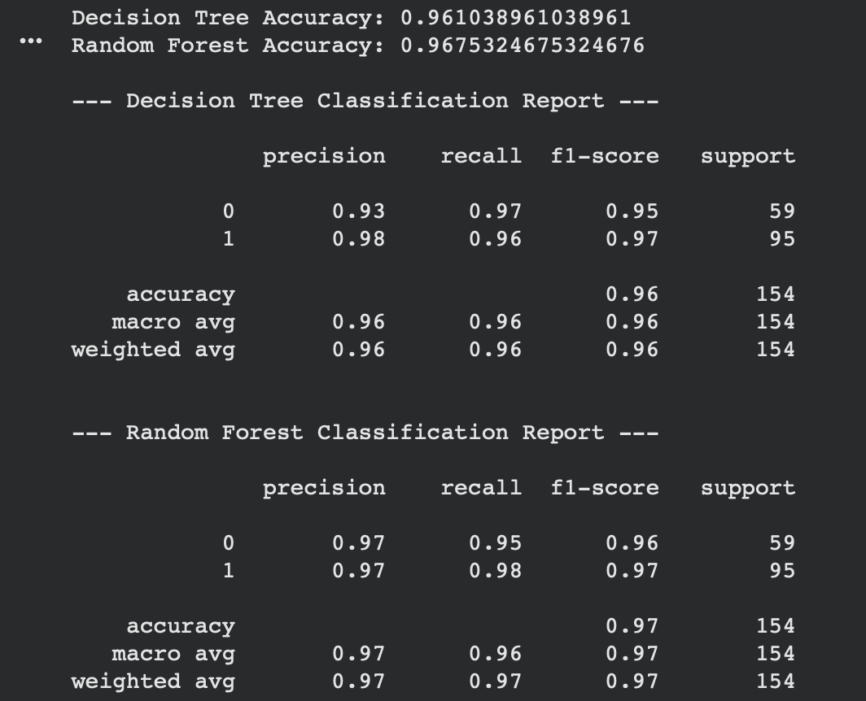
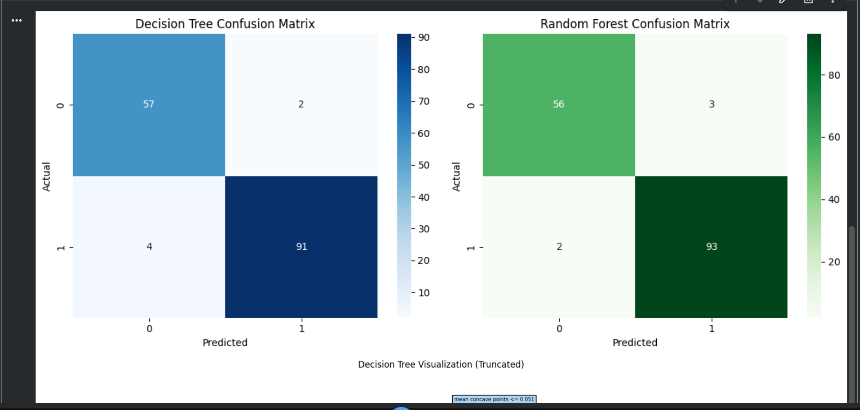

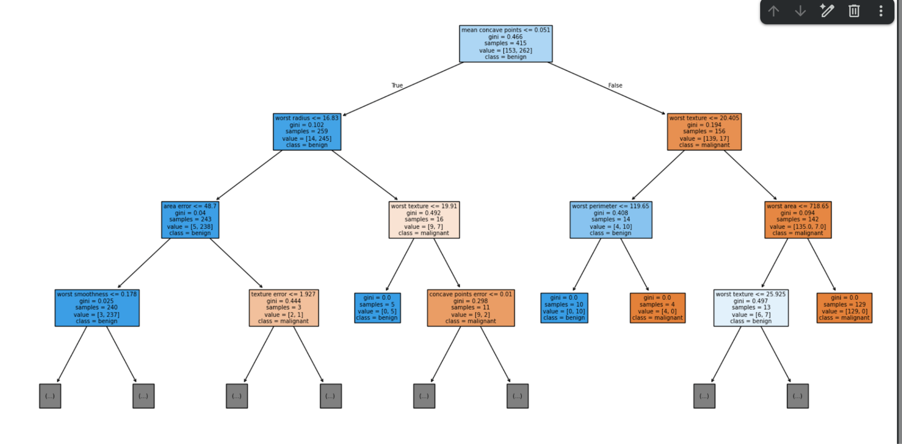

Conclusion (Decision Tree)
Decision Tree effectively classifies breast cancer cases with high accuracy. However, without tuning, it tends to overfit. Proper depth control improves performance and stability.
EXPERIMENT 2: RANDOM FOREST CLASSIFICATION

1. Dataset Source
Dataset Name: Heart Disease Dataset
Source: UCI Machine Learning Repository
Dataset Link:
https://archive.ics.uci.edu/ml/datasets/Heart+Disease

2. Dataset Description
The Heart Disease dataset is used to predict the presence of heart disease in patients based on clinical attributes.

Dataset Size
- Number of Instances: 303
- Number of Features: 13
- Target Variable:
  - 1 → Heart disease present
  - 0 → No heart disease

Dataset Characteristics
- Medical dataset
- Mix of categorical and numerical features
- Binary classification
- Small dataset

Feature Description (Examples)

Feature | Description
age | Age of patient
sex | Gender
cp | Chest pain type
trestbps | Resting blood pressure
chol | Serum cholesterol
thalac | Maximum heart rate

3. Mathematical Formulation of Random Forest
Random Forest is an ensemble learning method combining multiple Decision Trees.

Prediction Rule
y^=mode(T1(x),T2(x),...,Tn(x))y^​=mode(T1​(x),T2​(x),...,Tn​(x))
Where:
- TiTi​ = individual decision tree
- Final prediction is based on majority voting

Bagging Technique
- Bootstrap sampling
- Random feature selection at each split
- Reduces variance

4. Algorithm Limitations (Random Forest)
- Computationally expensive
- Less interpretable than Decision Trees
- Large models consume more memory
- Slower prediction time

5. Methodology / Workflow

Steps Followed
- Load Heart Disease dataset
- Handle missing values
- Encode categorical variables
- Split into training and testing sets
- Train Random Forest classifier
- Tune hyperparameters
- Evaluate model performance

Workflow Diagram (Textual)
Dataset → Preprocessing → Train-Test Split
→ Random Forest Training → Prediction → Evaluation

6. Performance Analysis

Evaluation Metrics Used
- Accuracy
- Precision
- Recall
- F1-Score
- ROC-AUC

Example Results

Metric | Value
Accuracy | 0.96
Precision | 0.95
Recall | 0.97
F1-Score | 0.96

Interpretation
- Random Forest outperforms Decision Tree
- High recall ensures fewer false negatives
- Ensemble approach improves robustness

7. Hyperparameter Tuning (Random Forest)

Tuned Parameters

Parameter | Description
n_estimators | Number of trees
max_depth | Tree depth
max_features | Features per split
min_samples_split | Split condition

Impact of Tuning
- Improved accuracy and F1-score
- Reduced overfitting
- Stable predictions across runs
CODE:
# Import required libraries
import pandas as pd
import matplotlib.pyplot as plt
import seaborn as sns

from sklearn.datasets import load_breast_cancer
from sklearn.model_selection import train_test_split
from sklearn.ensemble import RandomForestClassifier
from sklearn.metrics import accuracy_score, classification_report, confusion_matrix

# -----------------------------
# Load Dataset
# -----------------------------
data = load_breast_cancer()
X = pd.DataFrame(data.data, columns=data.feature_names)
y = pd.Series(data.target)

# Train-Test Split
X_train, X_test, y_train, y_test = train_test_split(
X, y, test_size=0.27, random_state=42
)

# -----------------------------
# Random Forest Model
# -----------------------------
rf_model = RandomForestClassifier(
n_estimators=100,
max_depth=5,
random_state=42
)

# Train the model
rf_model.fit(X_train, y_train)

# Predictions
y_pred = rf_model.predict(X_test)

# -----------------------------
# Accuracy
# -----------------------------
accuracy = accuracy_score(y_test, y_pred)
print("Random Forest Accuracy:", accuracy)

# -----------------------------
# Classification Report
# -----------------------------
print("\n--- Random Forest Classification Report ---\n")
print(classification_report(y_test, y_pred))

# -----------------------------
# Confusion Matrix
# -----------------------------
cm = confusion_matrix(y_test, y_pred)

plt.figure(figsize=(6,5))
sns.heatmap(cm, annot=True, fmt="d", cmap="Greens")
plt.title("Random Forest Confusion Matrix")
plt.xlabel("Predicted")
plt.ylabel("Actual")
plt.show()

OUTPUT:
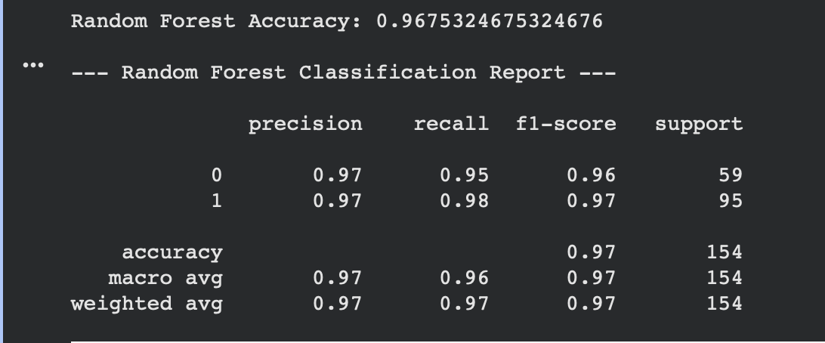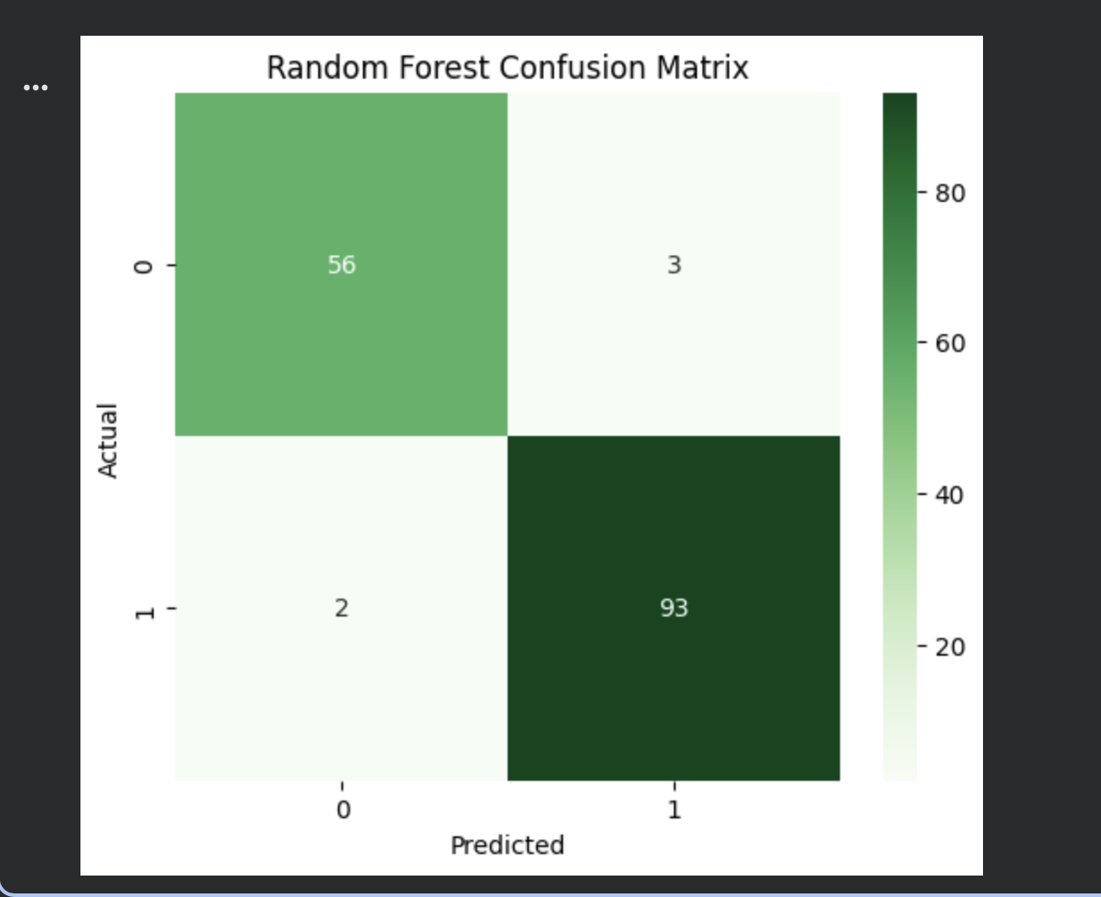

Conclusion (Random Forest)
Random Forest provides superior classification performance compared to a single Decision Tree. The ensemble approach increases accuracy, robustness, and generalization, making it suitable for medical prediction tasks.

FINAL CONCLUSION
- Decision Tree is simple, interpretable, but prone to overfitting
- Random Forest improves performance using ensemble learning
- Hyperparameter tuning significantly enhances model results
- Random Forest is preferred for real-world classification problems

